Yucehan Kucukmotor

CIS/STA3920, 7th Assignment

Professor: Lawrence Tatum

1. 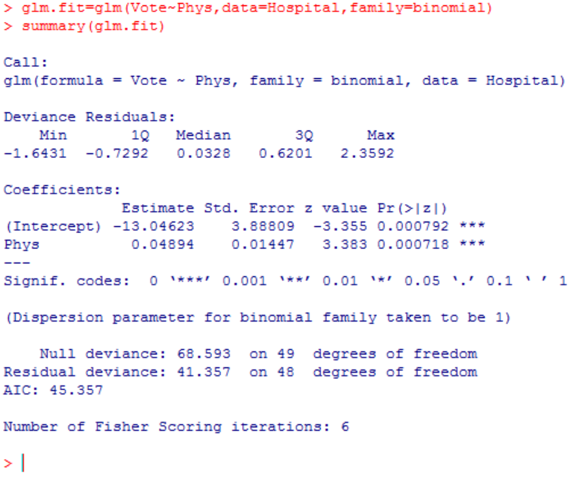

# Using Phys (Number of Physicians in the state per 100,000 residents) as my x-variable.

# summary function is to see output of the glm.fit

1. 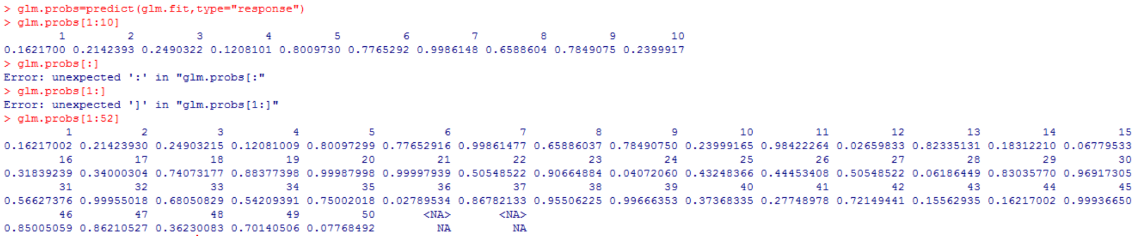

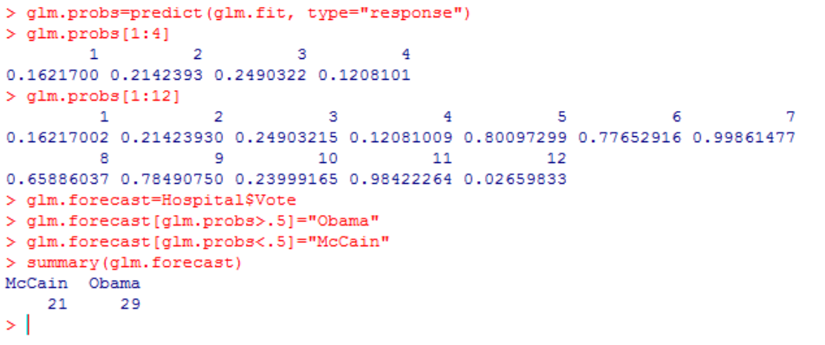

d) named the predict function glm.probs and displayed values 1 to 4 and then 1 to 12 to match the values with data on the excel file and see how good it is working. For values greater than .5, vote is Obama. Going back to the Excel file(Hospital.csv), we see, indeed, that first 4 states’ vote was McCain. And from 5th to 9th state the vote was Obama. Probabilities such as .16, .21, .24, etc. may seem exceptionally low and off, however it is good to keep in mind that we are working on a logistic regression between number of physicians in the state per 100,000 residents and the vote of that very state. Thus, it is expected.

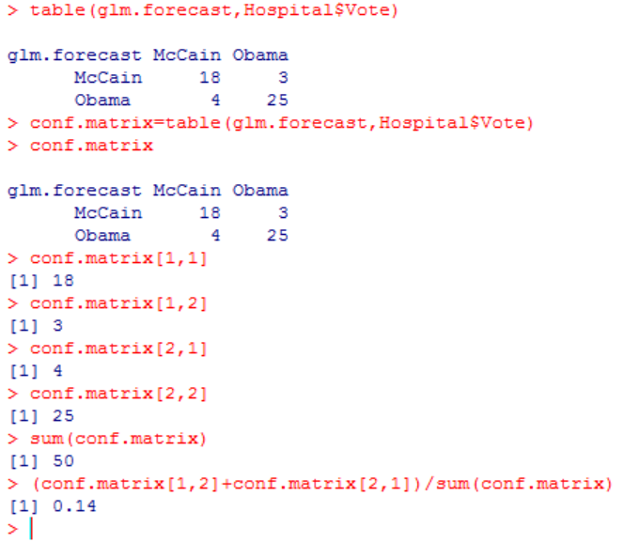

e) 7/50=.14 error rate of the forecast. This is done first manually on the lines of codes shown on the right side. This can also be automated. I named the table conf.matrix. Then using the proper row, column values, we can do the simple math.

conf.matrix[1,2]+conf.matrix[2,1]=7

sum(conf.matrix)=50

Thus, 7/50=.14 (Vote forecast error)

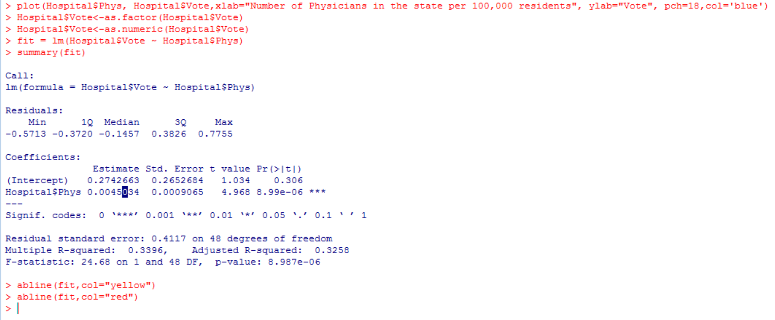

c) I could do a linear regression.

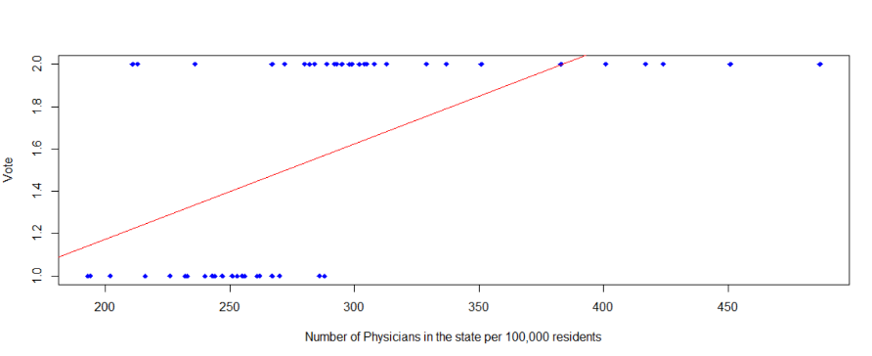

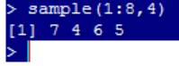7.2)

a) 7th, 4th, 6th, and 5th x-variables will be used

(SupSec, Medicare, SocChg, SocSec)

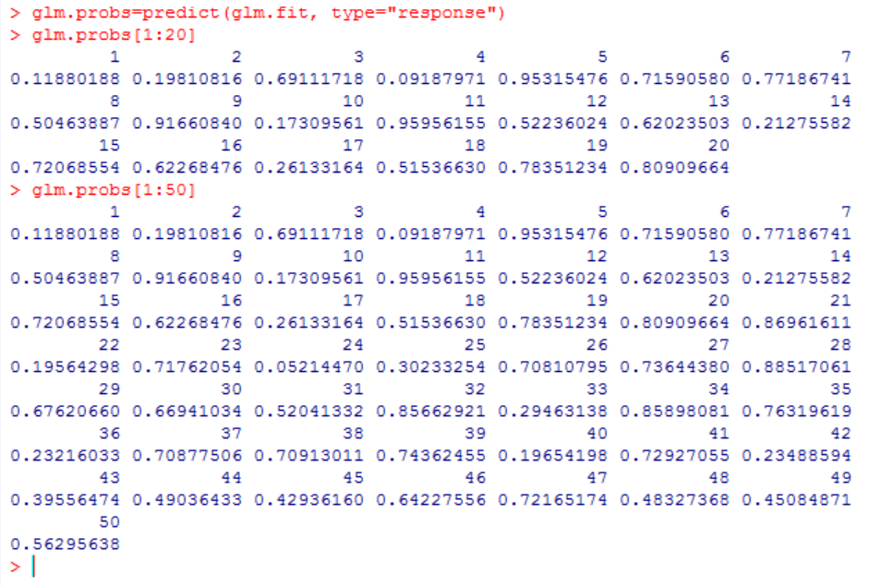 b) > glm.fit=glm(Vote~SupSec+Medicare+SocChg+SocSec, data=Hospital,family=binomial)

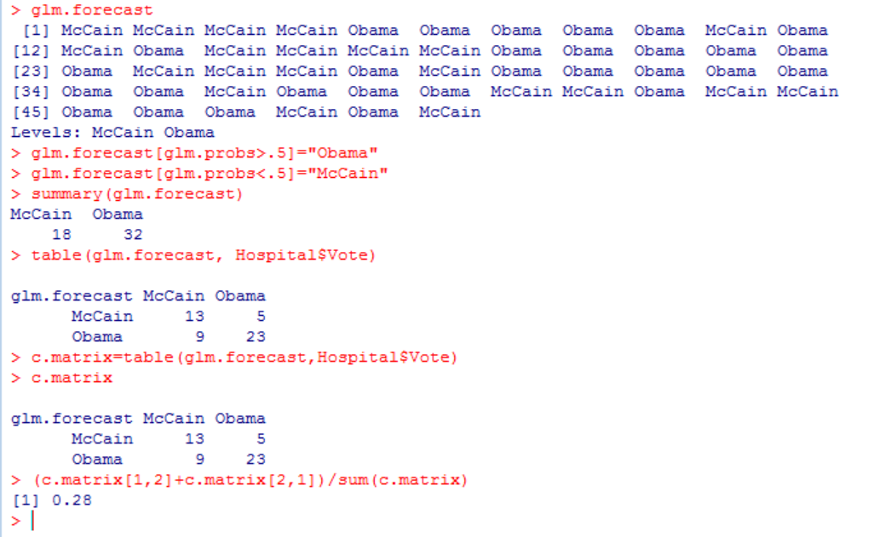 c) Vote Forecast Error is 28%

9+5/50=14/50=.28